IT 2080 – IT Project
Activity 1



Group Number - ITP25_WE_B01_01_204
Topic – Medical Center Management System
Team Members
IT Number | Student Name | Student Email Address | Contact Number
IT23588714 | K.H.S.Dinsara | it23588714@my.sliit.lk | 0703287271
IT23543232 | Navodya A.K. | it23543232@my.sliit.lk | 0764449102
IT23572638 | Thathsarani J R | it23572638@my.sliit.lk | 0703119829
IT23810464 | Ekanayaka E.W.I.D | it23810464@my.sliit.lk | 0768370886
IT23669758 | Liyanaarachchi L.A.D.A | it23669758@my.sliit.lk | 0772712630

Table of Contents

01. Problem Statement 3
02. Benefits that users will get from the System 4
1. Patient 4
2. Receptionist 4
3. Doctor 4
4. Lab Assistant 4
5. Pharmacist 5
6. Medical Center Manager 5
03. Mind Map 6
04. Features and user Requirements 7
1. Patient Requirements 7
2. Doctor Requirements 7
3. Nurse/Lab Assistant Requirements 8
4. Receptionist Requirements 8
5. Pharmacist Requirements 9
6. Manager Requirements 9
05. Name of the Project 10

Medical Center Management System

01. Problem Statement

Most medical centers still handle patient scheduling, treatment history, billing, and inventory using manual files or simple software. Schedule conflicts, incomplete medical records, delayed patient updates, and a breakdown in staff-patient communications are all too frequently the outcome. Medical personnel might not have up to the minute information on patient status, treatment plans, or medication supplies, while patients might be left unaware of pending appointments, test results, or billing status. Wasted time, added mistakes, and reduced patient satisfaction are the outcome of these inefficiencies. More intelligent systems are desperately needed to deliver seamless clinical workflow and patient care as the demand for healthcare grows.

We suggest creating a Medical Center Management System (MCMS), a centralized, intelligent web platform intended to optimize every facet of medical center operations. Online appointment scheduling, prescription medication delivery, medical record viewing, and billing information tracking are all available to patients. Effective care plan management, treatment progress updates, and real-time patient data access are all available to physicians and nurses. Inventory managers and administrative employees have access to tools and notifications that enhance resource planning and workflow. Healthcare executives and supervisors are able to optimize service efficiency and quality by creating reports. The ultimate goal of this system is to improve patient experience, eliminate clinical errors, and lessen administrative load.

02. Benefits that users will get from the System

1. Patient
- Book and manage appointments online.
- Receive real-time updates, appointment reminders, and test result notifications.
- Access personal health records, prescriptions, and treatment history.
- Make secure payments for consultations, lab tests, and procedures.
- View and approve treatment plans or procedure estimates.

2. Receptionist
- Create and manage patient appointments and visit schedules.
- Send appointment confirmations and reminders via notification.
- Register new patients and update personal or insurance details.
- Coordinate patient flow and reduce wait times.

3. Doctor
- Access and update electronic medical records (EMR) and case histories.
- View patient vitals, lab reports, and prescription history at a glance.
- Generate digital prescriptions and treatment plans.
- Communicate with patients securely for follow-up or telehealth sessions.

4. Lab Assistant
- Receive and manage assigned patient tasks and diagnostic test requests.
- Record vitals, observations, and medication administration digitally.
- Upload test results and collaborate with doctors on care plans.
- Track consumables and report inventory usage.

5. Pharmacist
- Manage and categorize medicines, lab kits, and medical supplies.
- Track inventory usage and get alerts when stock is low or nearing expiry.
- Monitor supplier performance and manage order history.

6. Medical Center Manager
- Access detailed reports on patient flow, revenue, and staff performance
- Configure services, pricing, doctor availability, and operating hours
- Monitor system-wide performance, department load, and resource utilization.
- Set automation rules for reminders, approvals, and escalation procedures.

03. Mind Map
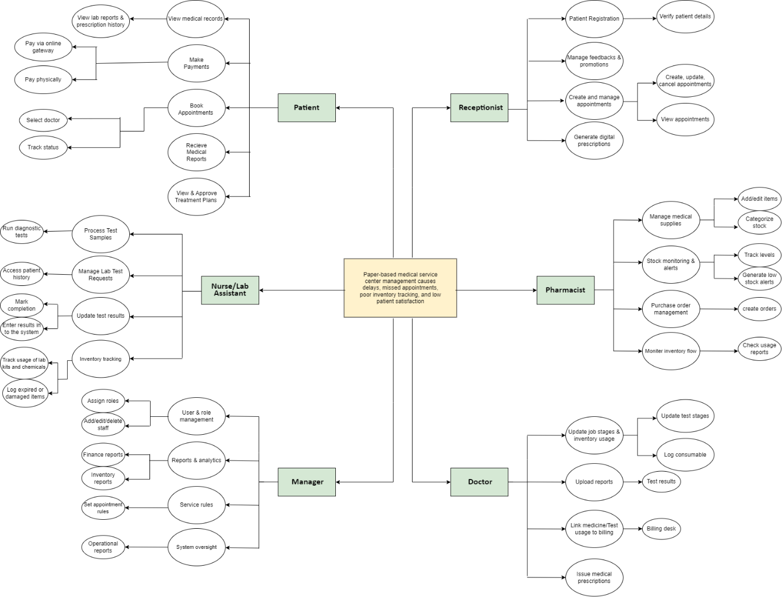

04. Features and user Requirements

1. Patient Requirements

Feature | User Requirement
Appointment Booking | Book appointments, select doctor.
Payment | Pay online via gateway or physically
 | Track appointment status
  Status Tracking
Receive Reports | Patient can view service and medical reports.
Get Notifications | Patient will receive reminders and confirmations.

2. Doctor Requirements

Feature | User Requirement
Manage medical reports | Upload patient reports
Inventory Usage | Update job stages & log consumable/test usage
Treatment Linkage | Link medicine/test usage to billing.
Generate Prescription | Issue medical prescriptions

3. Nurse/Lab Assistant Requirements

Feature | User Requirement
Sample Handling | Process test samples.
Lab Test Management | Manage lab test requests.
Inventory Tracking | Track lab kits/chemical usage.
Test Reporting | Update and enter test results into the system.
History Access | Access patient history

4. Receptionist Requirements

Features | User Requirements
Patient Registration | Register patients and verify details.
Appointment Management | Create, update, cancel appointments - view appointments.
Prescriptions | Generate digital prescriptions.
Promotions & Feedback | Manage patient feedback and promotions.

5. Pharmacist Requirements

Features | User Requirements
Medical Supply Management | Add/edit items, categorize stock.
Inventory Monitoring | Track levels, generate low stock alerts.
Order Handling | Create purchase orders, monitor inventory flow.
Usage Reporting | Check medicine/test usage reports.

6. Manager Requirements

Features | User Requirements
Staff Management | Assign roles, add/delete staff
Role & Access Control | Manage users and roles
Reporting & Analytics | Generate finance, inventory, and operational reports
System Oversight | Monitor and manage the entire system

05. Name of the Project

➢ “Medi Cura “– Medical Service Center Management System

